Flash/No-Flash Image Synthesis: Photo Enhancement through Denoising, Detail Transfer, & Color Preservation

Abigail Skerker, Jìa Wilkins



Boston University
Department of Electrical and Computer Engineering
8 Saint Mary’s Street
Boston, MA 02215
www.bu.edu/ece

Apr. 10, 2024

Technical Report No. ECE-2024-2
Contents

- Introduction 1
- Augmented Review of Literature 2
- Denoising & Detail Transfer Algorithm 4
- Experimental Results So Far 6
- Next Steps 9
- Appendix 10
- References 11

1 Introduction

In low-light settings, capturing images that successfully convey the visual richness of real environments poses a significant challenge in photography. Photographers traditionally have had to choose between utilizing long exposure times, larger apertures, increased gain or adding artificial light sources through a flash. However, while each of these techniques presents both benefits and drawbacks to capturing fidelitous images, we hope to implement an algorithm to highlight the best and mitigate the worst features of each approach. A list of these attributes with their pros and cons are listed below:

• Exposure Time: by providing more light to the sensor via a longer exposure, more low-light details from the original scene can be captured. However, camera shakes or scene motion during long exposures will result in motion blur, greatly affecting image fidelity.

• Aperture: by letting additional light into the sensor via a larger aperture, a greater level of detail can also be achieved. However, larger apertures are constrained by the physical limits of the lens and also reduce the depth of field, which may not be desired.

• Gain: by applying an amplification factor to all pixels, one can create a brighter image. However, when exposure time is short, the camera cannot capture enough light to accurately estimate the color at each pixel, thus increasing image noise.

• Flash: finally, by adding artificial light sources to the scene, photographers are able to use shorter exposure times, smaller apertures, and lower gains while still capturing enough information to produce sharp, noise-free images. However, objects near the camera are disproportionately brightened, the mood evoked by ambient illumination may be destroyed, and unwanted artifacts such as specular highlights may be introduced from the flash.

2 Augmented Review of Literature

Given the above constraints, photographers often find themselves limited in their ability to effectively capture every aspect of a scene as desired when working with only a single image. However, if the photographed scene is static or nearly static, two images can be captured one after the other in quick succession – one with flash to capture detail and one without flash to capture ambient illumination. When properly combined, image fidelity can benefit from both the low-noise and high-detail of a flash-exposed picture as well as the natural colors and reduced shadows from the no-flash exposure. This method is outlined by Petschnigg et al. in the 2004 paper “Digital Photography with Flash and No-Flash Image Pairs,” wherein they were able to meld flash and no-flash image pairs to produce a final image that accurately communicates the true lighting, details, and overall mood of the original low-light scene.

2.1 Bilateral Filtering Variations
Almost every technique for synthesizing higher quality images from flash/no-flash pairs relies on bilateral filtering, a process described in Tomasi and Manduchi’s 1998 paper “Bilateral Filtering for Grey and Color Images.” A bilateral filter achieves simultaneous noise reduction and edge preservation by applying an edge stopping function to a normal low-pass filter such that the filter weights are lower when the difference in intensity between two pixels is higher. When applied uniformly across color channels, the bilateral filter is able to effect noise reduction and edge preservation for both greyscale and color images [1].
In “Digital Photography,” the authors defined the filter at each weight as a product of two Gaussian distributions, one dependent on spatial distance (the low-pass filter) and the other on pixel intensity difference (the edge stopping function) [2]. However, in a 2015 paper “Rayleigh based Bilateral Filtering for Flash and No-Flash Images Pairs,” the authors describe an alternative approach centered on using a Rayleigh distribution instead of a Gaussian distribution for a bilateral filter, resulting in smoother denoising with the modified filter [3].
Returning to our primary guide paper, Petschnigg et al. also implements a “joint bilateral filter” which applies the same technique as normal bilateral filtering except that its edge stopping function is defined by the intensity difference between pixels in the flash image, not the ambient image. When performing detail transfer, the final image is determined by the product of the noise-reduced ambient image, achieved through the joint bilateral filter, and a detail image produced from the flash image [2].

2.2 Flash Artifact Mitigation
The joint bilateral filter approach leaves behind several artifacts or details produced by the flash image because of the extra light source: specular highlights and flash shadows. To mitigate such artifacts, a mask is produced to defer to the simple bilateral filter of the ambient image in affected areas. After linearizing the image pair to standardize ISO & exposure settings, areas of flash shadow should appear identical between the two captures; thus, comparing the two and applying a small threshold to account for noise, a shadow mask can be generated. For specular highlights, areas of sensor saturation are detected with a simple luminance threshold. An alternate approach to handling detail capture and flash shadow mitigation is defined in Eisemann and Durand’s 2004 research “Flash Photography Enhancement via Intrinsic Relighting,” wherein both the flash and no-flash images are decomposed into color and intensity (large scale & fine detail) images before recombination [4].

2.3 Red-Eye Removal
Petschnigg et al. also describes a methodology for handling red-eye correction. Areas of interest are first identified by converting both flash and ambient images to YCbCr chromaticity space, thus separating out red chrominances above a certain threshold in the flash compared to ambient image. By also discriminating for low luminances in the ambient image, red-eye candidates can be determined by searching for elliptically shaped anomalies. Using the same artifact mask for flash highlight and shadow removal, specular highlights in the eye are preserved while the red pixels are replaced with an appropriately luminant gray pupil color [2].

3 Denoising & Detail Transfer Algorithm

The Petschnigg et al. algorithm can be effectively summarized in a single block diagram, as shown below [2]:
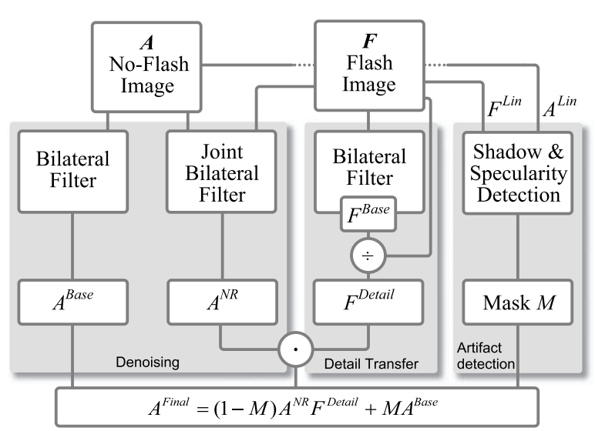
Fig. 1 Denoising & Detail Transfer Algorithm Block Diagram

3.1 Bilateral Filter & Joint-Bilateral Filter
To implement the above denoising and detail transfer algorithm, two filter functions are needed: a bilateral filter and a joint bilateral filter. The bilateral filter is applied to both the flash image and non-flash image. A bilateral filter is described by the equation below:
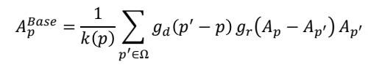 (eq. 1)
Where:
• A is the non-flash image being filtered
• p is a point or pixel in the image
• g_{d} is a function that sets the weight in the spatial domain based on the distance between the pixels (lowpass filter); g_{d} is a gaussian parametrized by σ_{d}.
• g_{r} is a function that sets the weight in the spatial domain based on how similar two pixels are in value (edge-stopping function); g_{r} is a gaussian parametrized by σ_{r}.
• k(p) is a normalization term defined below:
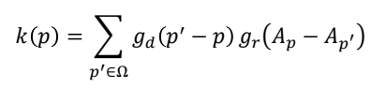 (eq. 2)
The joint bilateral filter is defined almost identically to the bilateral filter except that the edge-stopping function is a function of the flash image F rather than the ambient image A:
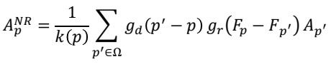 (eq. 3)

3.2 Detail Transfer, Artifact Mitigation, & Final Synthesis
The detail transfer function is defined on the flash image F to produce F^{Detail}. A small constant ε = 0.02 is also added for low signal noise mitigation and divide by zero errors:
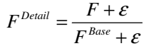 (eq. 4)
The flash artifact mask is computed by first linearizing F and A to produce F’^{Lin} and A’^{Lin}, which are then also normalized for ISO values and exposure time (Δt):
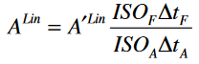 (eq.5)
These linearized images are then to determine a mask of flash shadow locations as identical areas between F^{Lin} and A^{Lin} within a parameter τ_{Shad}:
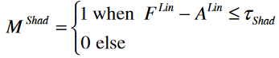 (eq. 6)
With an additional mask of specular highlights from the flash image M^{Spec} defined simply as areas in F^{Lin} with luminosity greater than 95% of the sensor maximum, a union of the two produces a final mask M that, following a simple blur to eliminate harsh edges, is implemented in the final synthesis equation:
(eq. 7)

4 Experimental Results So Far

To date, we have implemented the denoising and detail transfer algorithm described in the Petschnigg et al. paper from scratch using MATLAB. Shown below in figure 2 is a demonstration of this algorithm applied to the “Carpet” image sourced from the paper’s dataset [2]. The figure titles match the block diagram in the Algorithm section. Note that to help the algorithm run in efficient time, the images were downsampled from 2048x3072 to 512x768, or by a factor of 4 in each direction.
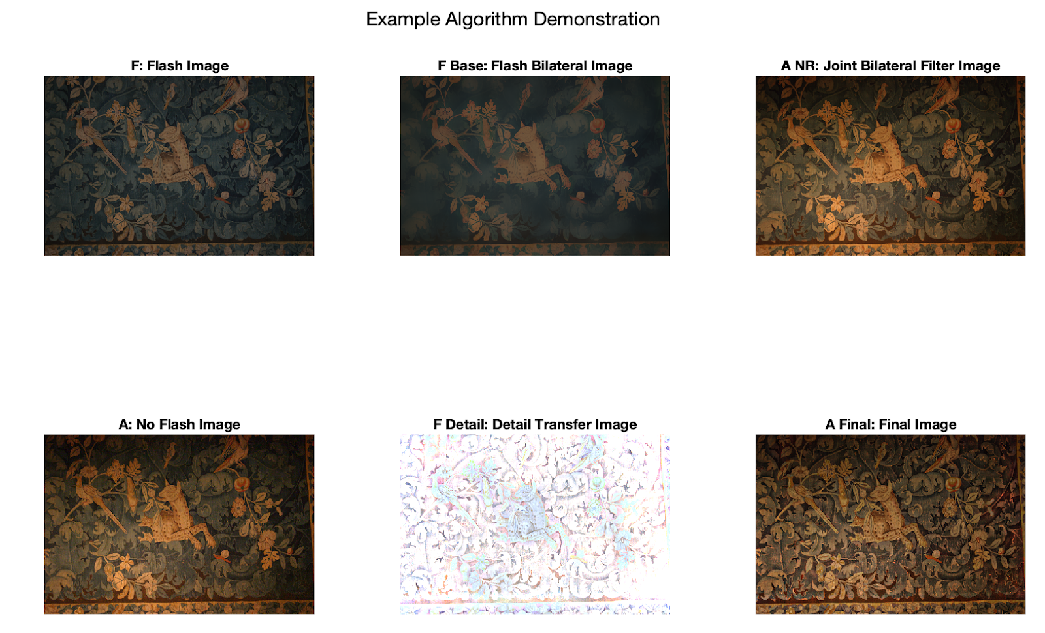
Fig. 2 Demonstration of Detail Transfer & Denoising Algorithm on “Carpet”
Figure 3 offers a zoomed in view to highlight the detail transfer applied in the face of the leopard on the carpet. It can be seen that there is additional resolution on the final image that is not in the original image, while still retaining most of the color from the no flash image as intended by the algorithm.
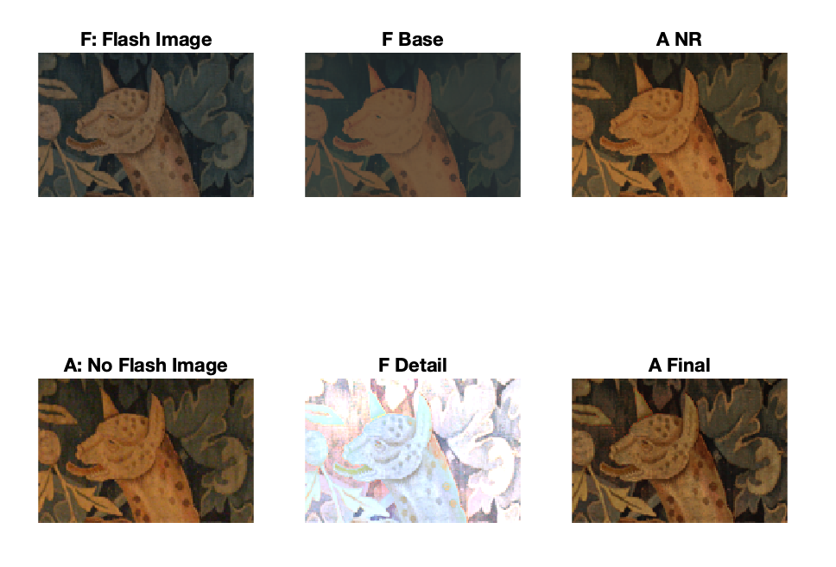
Fig. 3 Demonstration of Detail Transfer & Denoising Algorithm on “Carpet,” Leopard

4.1 Parameter Experiments
Parameters described in the algorithm section were modified to assess their impact on the detail transfer algorithm, including the filter width, σ_{d}, σ_{r,} and M. By increasing the filter width in figure 4 below, additional detail is included on the final image, where the color does not seem to be affected. This effect is seen when increasing from a filter width of 5 to 10 and 10 to 20 but is less obvious from 20 to 40. Note the actual filter width is double plus one what is described, as it describes the neighborhood width from the pixel.
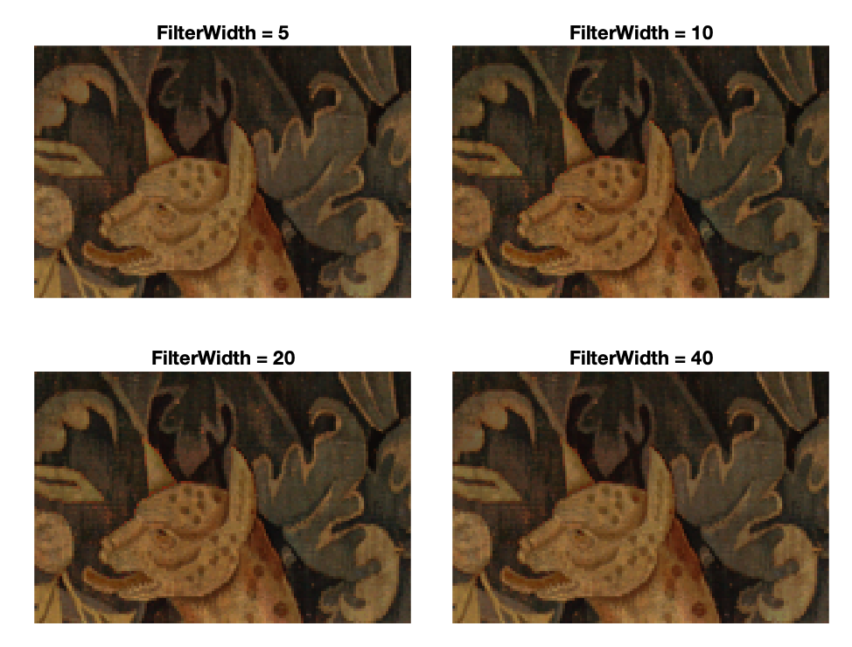
Fig. 4 Effect of Filter Width on Leopard Face
The standard deviation on the distance gaussian, σ_{d}, controls the width of the low-pass filter. The visual differences between the two σ_{d} parameters are less visually evident than with other parameters. In the Petschnigg paper, it is recommended to set this parameter between 24 and 48 [2].
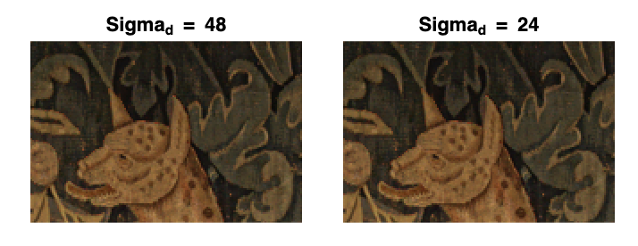
Fig. 5 Effect of σ_{d} on Leopard Face
The standard deviation on the distance gaussian, r, controls the width of the gaussian on the edge stopping function. It can be observed that details are clearer with a larger σ_{r} from the below images.
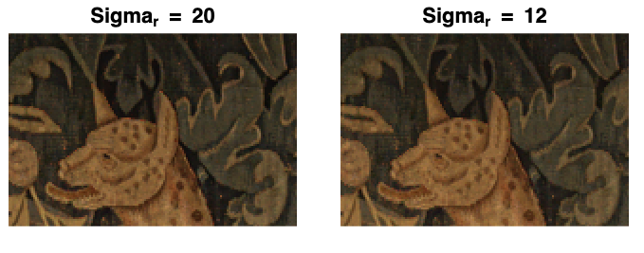
Fig. 6 Effect of σ_{r} on Leopard Face
The mask M controls how much the detail-transfer image versus the denoised image affects the final result. As defined in the algorithm section, a technique exists for calculating the mask, but this has not yet been implemented in the MATLAB algorithm, so a simple uniform mask is tested to showcase its theoretical effects: by increasing the mask weight, less of detail is preserved but more of the original coloring from the no flash image comes through.
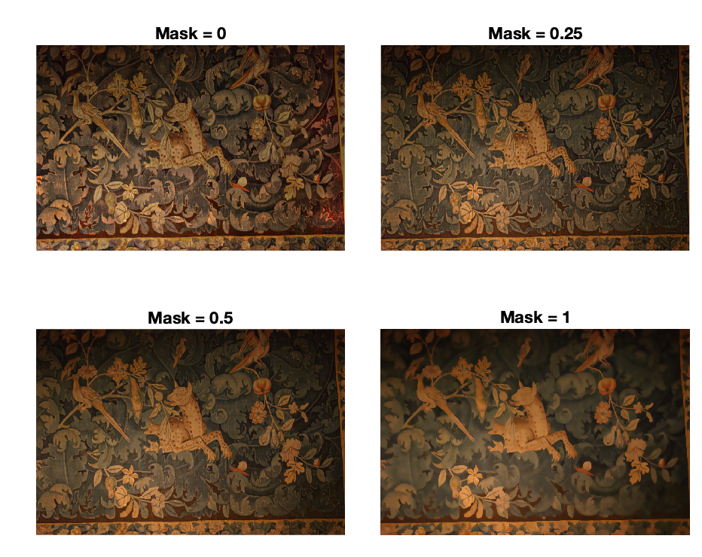
Fig. 6 Effect of Mask M on “Carpet”

5 Next Steps

For the final report, we plan to perform the following additional steps:

- Continued Work on Algorithm
There is significant additional optimization and testing to be done on the detail transfer algorithm. For optimization, steps can be taken to speed up the runtime of the algorithm such that it can be run on the full resolution image in a reasonable amount of time. Finally, we still need to implement the detection of flash shadows and specularities algorithm to generate mask M.

- Continued Testing on Algorithm
There is also additional testing planned, from testing the algorithm with the full set of provided images to better tune the parameters and assess fidelity to comparing our created bilateral and joint bilateral filters with the built in MATLAB functions for performance. Lastly, we will compare the results we obtain from our detail transfer algorithm with the provided results from the paper.

- Testing with Original Images
We plan to acquire a high-quality camera and tripod from a friend to capture our own flash/no-flash image pairs for testing; we hope to capture a wide range of indoor and outdoor lowlight images with reflective and matte detailed surfaces in various 3D configurations to test our implantation to the fullest.

- Red-Eye Correction
We finally also plan on implementing the red-eye correction algorithm described at the end of the Petschnigg et al. paper.

Appendix
The Matlab source code developed for this project so far can be found at the following address: https://github.com/jcw0525/ec520_flash
References

[1] C. Tomasi and R. Manduchi, "Bilateral filtering for gray and color images," Sixth International Conference on Computer Vision (IEEE Cat. No.98CH36271), Bombay, India, 1998, pp. 839-846, doi: 10.1109/ICCV.1998.710815.

[2] Georg Petschnigg, Richard Szeliski, Maneesh Agrawala, Michael Cohen, Hugues Hoppe, and Kentaro Toyama. 2004. Digital photography with flash and no-flash image pairs. ACM Trans. Graph. 23, 3 (August 2004), 664–672. https://doi.org/10.1145/
1015706.101577

[3] A. K. Sinha, V. Bhateja, and A. Sharma, "Rayleigh based bilateral filtering for flash and no-flash image pairs," 2015 2nd International Conference on Signal Processing and Integrated Networks (SPIN), Noida, India, 2015, pp. 559-563, doi: 10.1109/SPIN.2015.
7095418.

[4] Elmar Eisemann and Frédo Durand. 2004. Flash photography enhancement via intrinsic relighting. ACM Trans. Graph. 23, 3 (August 2004), 673–678. https://doi.org/
10.1145/1015706.1015778

